7.16 - Derive expressions for each T flip-flop input, then sketch the circuit.
Repeat 1. using D-type flip-flops

Question:

Solution:

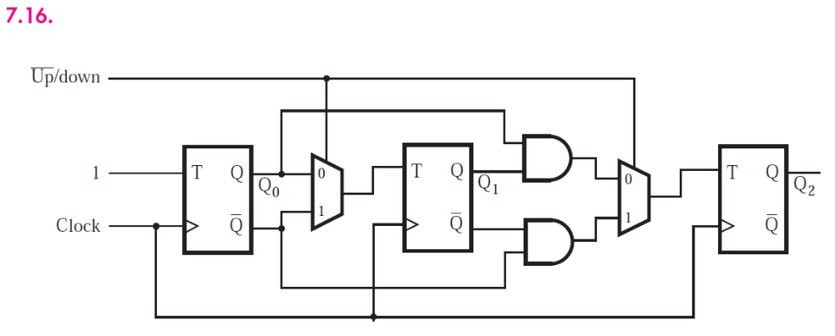

7.21

Question:

Solution:

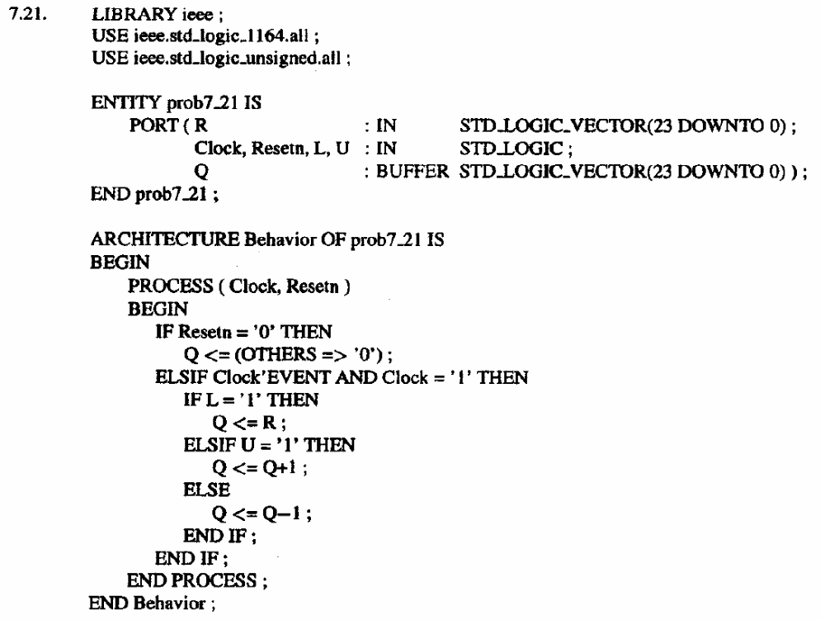

7.28

Question:

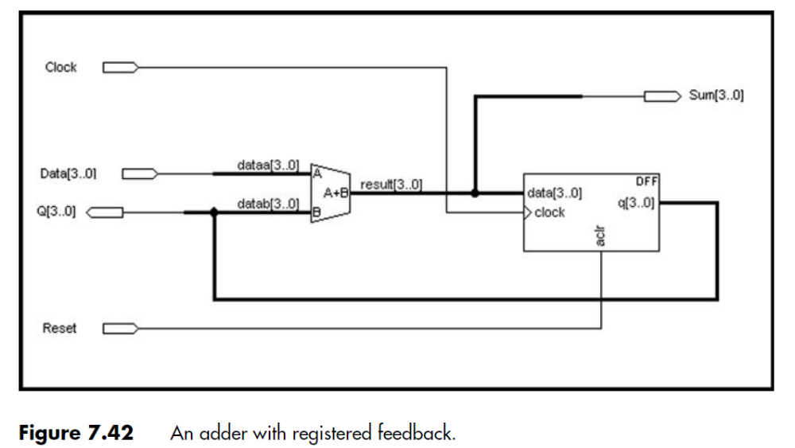

Solution:

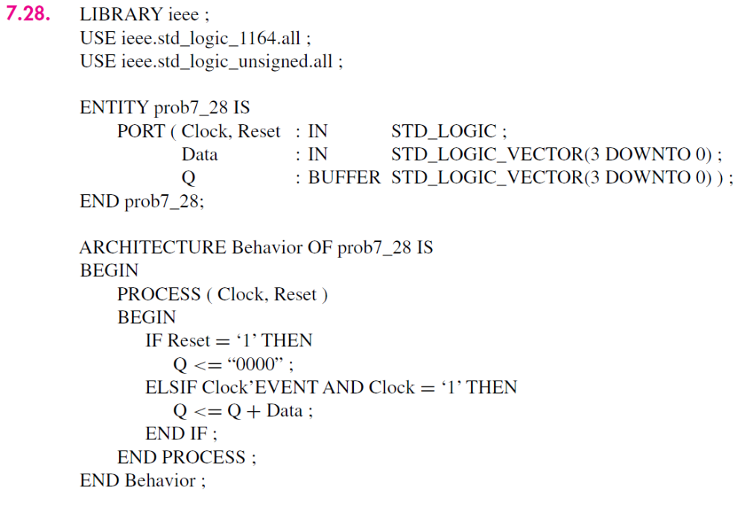

7.33

Question:

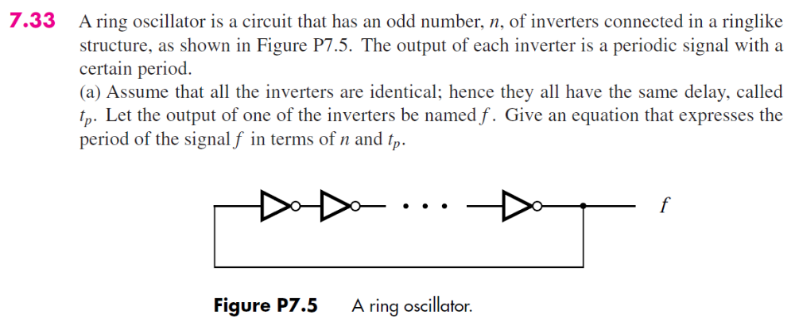
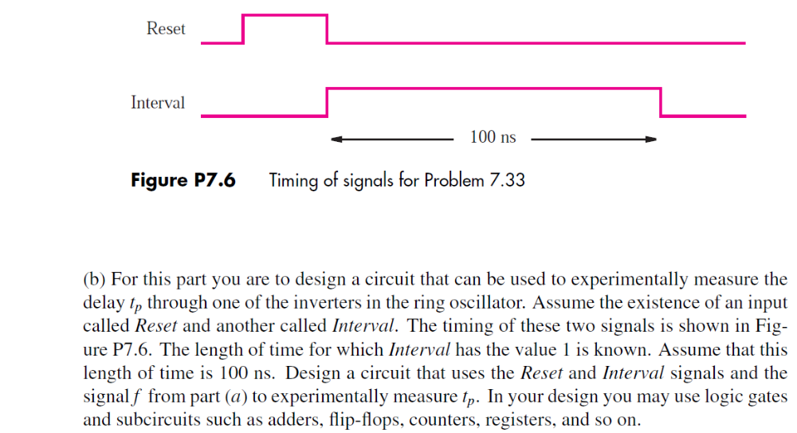

Solution:

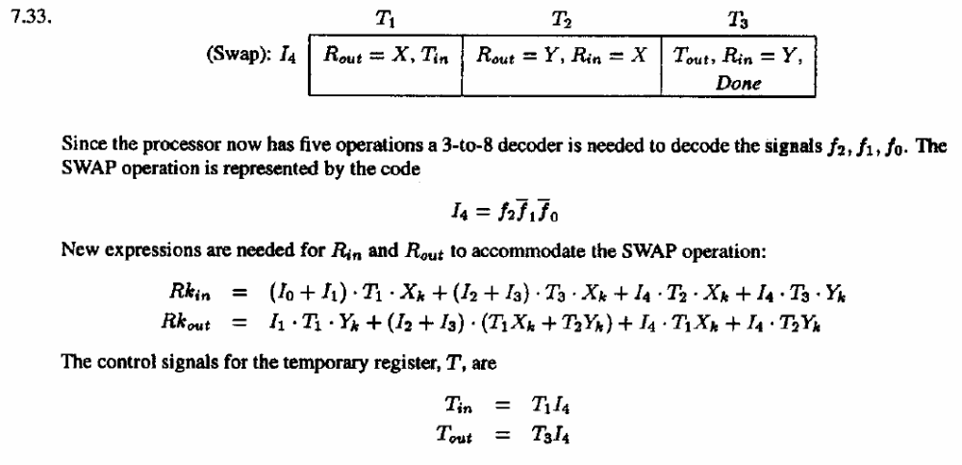

7.34 - What is Tcq for 0->1 and 1->0 transitions?

Question:

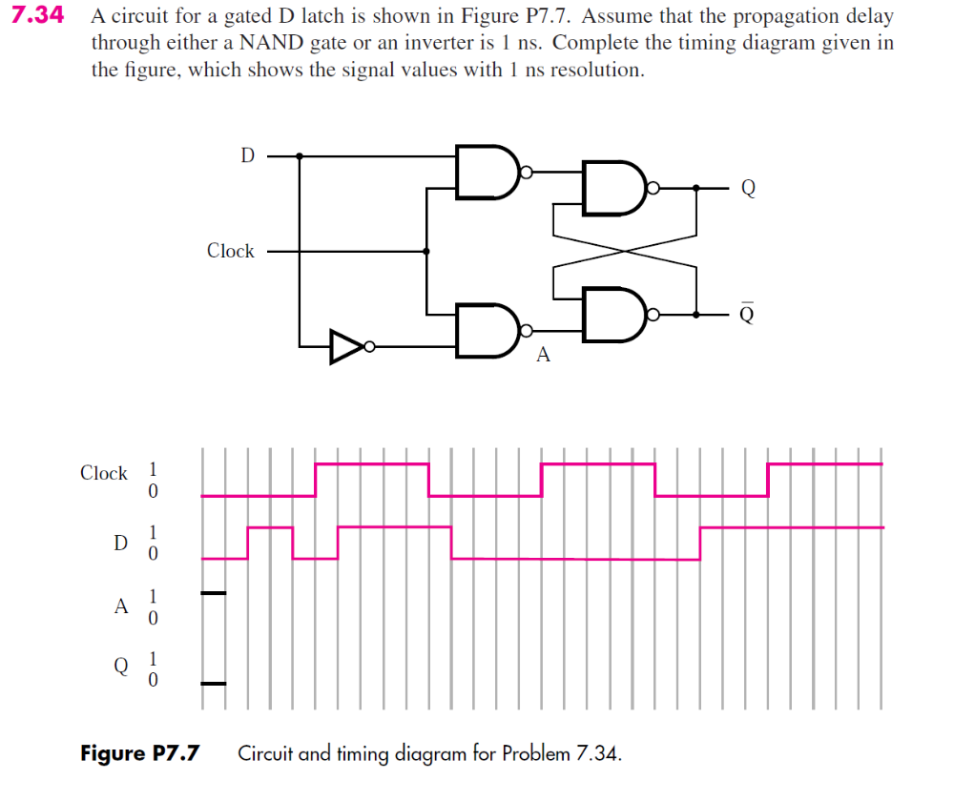

Solution:

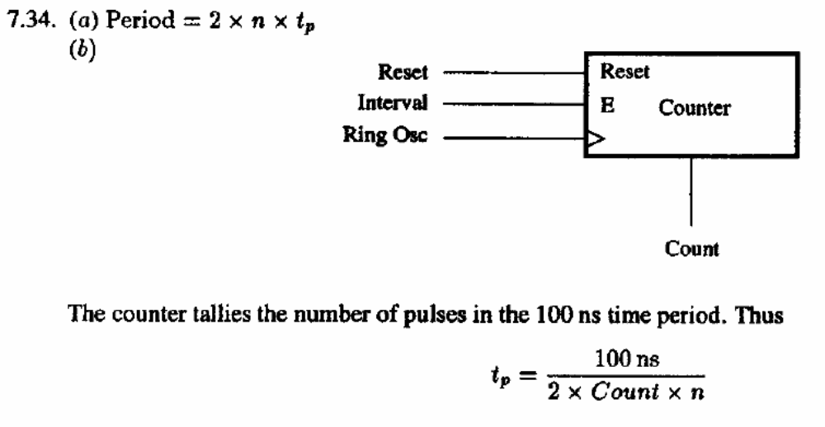

Question:

Modify the VHDL code of 3. above by adding a parameter that determines the number of flip-flops in the counter. Describe the changes that must be made to the code.

